OBSERVATIONS

The three observations about the results of the study showing how four treatments (Capomulin, Infubinol, Ketapril, and Placebo) compare.

1. Out of the four drugs used only Capomulin provided reduction (19%) in tumor, rest of the drugs failed to reduce tumor as it grew approximately 50% more during the 45 days trial period.

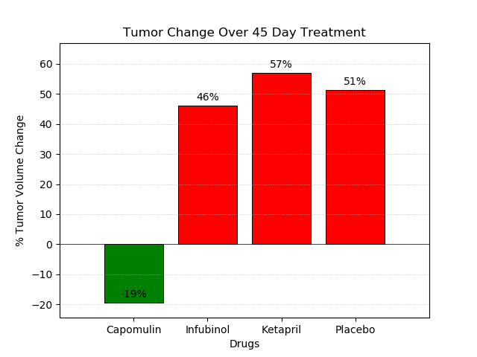

1. Metastatic spread trends suggest that Capomulin and Infubinol applied mice have significant reduction in the spread of tumor after 10 days till end of the experiment, but the Ketapril and Placebo continued to spread at higher rates all through the study period.

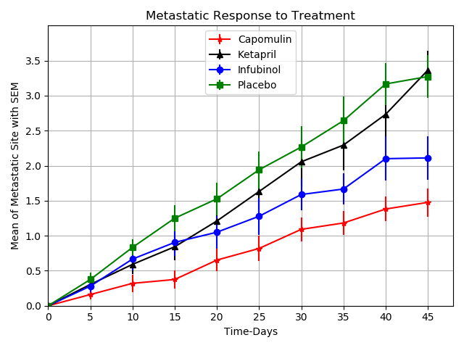

1. Among the four drugs Capomulin showed maximum mouse survival rate at 84% after the 45 days of experiment, whereas Ketapril and Placebo gave 44% survival of mice during the same period. Among the four drugs the least survival was for Infubinol at 36%. Capomulin has consistently given higher rate of survival at every stage of the experiment. However, the rate of survival among Ketapril, Placebo and Infubinol shows relative variations at different stages of the experiment.

